Testing archi with github
16 May 2024 10:45:12

 | Purpose
 | Testing archi with github | 2 | / 52
 | Views
 | ARCHI 3.2 Reference Model
 | No viewpoint
 | 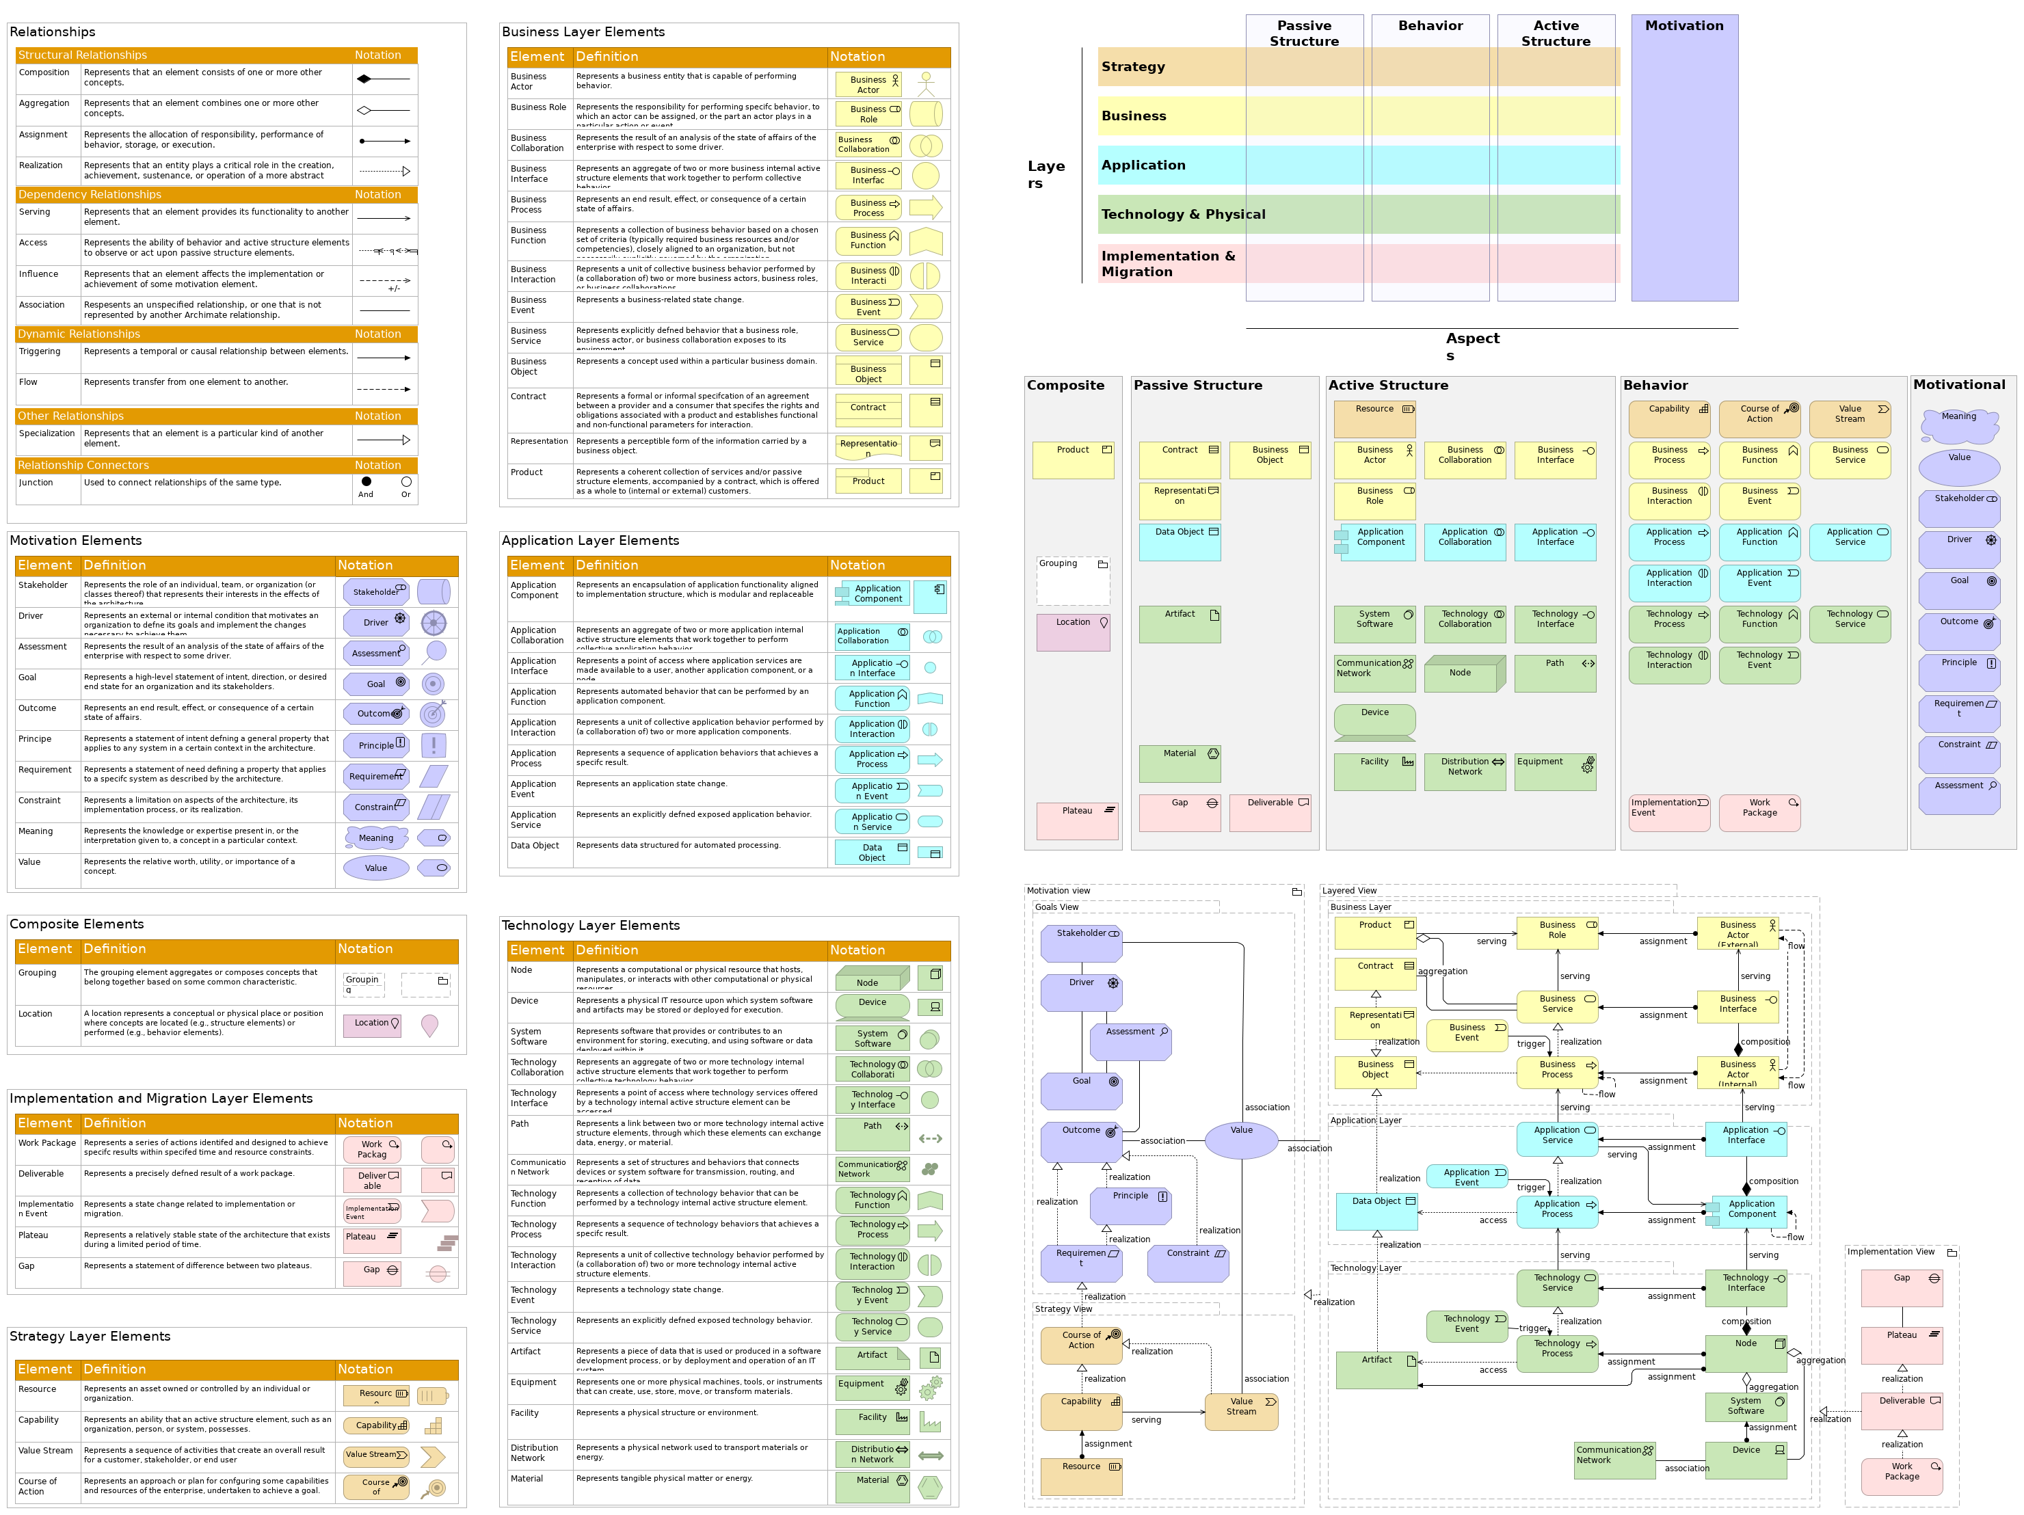
 | Elements
 | Element | Type
 | Meaning | Meaning
 | Stakeholder | Stakeholder
 | Principle | Principle
 | Goal | Goal
 | Driver | Driver
 | Outcome | Outcome
 | Requirement | Requirement
 | Value | Value
 | Assessment | Assessment
 | Constraint | Constraint
 | Resource | Resource
 | Capability | Capability
 | Value Stream | Value Stream
 | Testing archi with github |  | 3 | / 52
 | Element | Type
 | Course of Action | Course of Action
 | Business Actor | Business Actor
 | Business Role | Business Role
 | Business Collaboration | Business Collaboration
 | Business Interface | Business Interface
 | Business Process | Business Process
 | Business Function | Business Function
 | Business Interaction | Business Interaction
 | Business Event | Business Event
 | Business Service | Business Service
 | Business Object | Business Object
 | Contract | Contract
 | Representation | Representation
 | Product | Product
 | Data Object | Data Object
 | Application Service | Application Service
 | Application Event | Application Event
 | Application Process | Application Process
 | Application Interaction | Application Interaction
 | Application Function | Application Function
 | Application Interface | Application Interface
 | Application Collaboration | Application Collaboration
 | Application Component | Application Component
 | Node | Node
 | Device | Device
 | System Software | System Software
 | Technology Collaboration | Technology Collaboration
 | Technology Interface | Technology Interface
 | Path | Path
 | Communication Network | Communication Network
 | Technology Service | Technology Service
 | Technology Event | Technology Event
 | Technology Interaction | Technology Interaction
 | Technology Process | Technology Process
 | Technology Function | Technology Function
 | Equipment | Equipment
 | Facility | Facility
 | Distribution Network | Distribution Network
 | Material | Material
 | Work Package | Work Package
 | Deliverable | Deliverable
 | Implementation Event | Implementation Event
 | Plateau | Plateau
 | Gap | Gap
 | Testing archi with github |  | 4 | / 52
 | Element | Type
 | Grouping | Grouping
 | Location | Location
 | Application Collaboration | Application Collaboration
 | Application Component | Application Component
 | Application Event | Application Event
 | Application Function | Application Function
 | Application Interaction | Application Interaction
 | Application Interface | Application Interface
 | Application Layer | Grouping
 | Application Process | Application Process
 | Application Service | Application Service
 | Artifact | Artifact
 | Artifact | Artifact
 | Assessment | Assessment
 | Business Actor | Business Actor
 | Business Collaboration | Business Collaboration
 | Business Event | Business Event
 | Business Function | Business Function
 | Business Interaction | Business Interaction
 | Business Interface | Business Interface
 | Business Layer | Grouping
 | Business Object | Business Object
 | Business Object | Business Object
 | Business Object (copy) | Business Object
 | Business Object (copy) (copy) | Business Object
 | Business Process | Business Process
 | Business Role | Business Role
 | Business Service | Business Service
 | Capability | Capability
 | Communication Network | Communication Network
 | Constraint | Constraint
 | Contract | Contract
 | Course of Action | Course of Action
 | Data Object | Data Object
 | Deliverable | Deliverable
 | Device | Device
 | Distribution Network | Distribution Network
 | Driver | Driver
 | dummy | Application Service
 | dummy | Application Service
 | Dummy | Application Component
 | dummy | Outcome
 | dummy | Requirement
 | dummy (copy) | Application Service
 | Testing archi with github |  | 5 | / 52
 | Element | Type
 | dummy (copy) | Application Service
 | dummy (copy) | Application Service
 | dummy (copy) | Application Service
 | Dummy (copy) | Application Component
 | dummy (copy) | Application Service
 | dummy (copy) | Application Service
 | dummy (copy) (copy) | Application Service
 | dummy (copy) (copy) | Application Service
 | dummy (copy) (copy) | Application Service
 | Dummy (copy) (copy) | Application Component
 | dummy (copy) (copy) | Application Service
 | dummy (copy) (copy) | Application Service
 | dummy (copy) (copy) | Application Service
 | dummy (copy) (copy) (copy) | Application Service
 | dummy (copy) (copy) (copy) | Application Service
 | dummy (copy) (copy) (copy) | Application Service
 | dummy (copy) (copy) (copy) | Application Service
 | dummy (copy) (copy) (copy) | Application Service
 | dummy (copy) (copy) (copy) | Application Service
 | dummy (copy) (copy) (copy) (copy) | Application Service
 | dummy (copy) (copy) (copy) (copy) | Application Service
 | dummy (copy) (copy) (copy) (copy) | Application Service
 | dummy (copy) (copy) (copy) (copy) | Application Service
 | dummy (copy) (copy) (copy) (copy) (copy) | Application Service
 | dummy (copy) (copy) (copy) (copy) (copy) (copy) | Application Service
 | dummy (copy) (copy) (copy) (copy) (copy) (copy) | Application Service
 | dummy (copy) (copy) (copy) (copy) (copy) (copy) | Application Service
 | dummy (copy) (copy) (copy) (copy) (copy) (copy) | Application Service
 | Equipment | Equipment
 | Facility | Facility
 | Gap | Gap
 | Goal | Goal
 | Goals View | Grouping
 | Grouping | Grouping
 | Implementation Event | Implementation Event
 | Implementation View | Grouping
 | Layered View | Grouping
 | Location | Location
 | Material | Material
 | Meaning | Meaning
 | Motivation view | Grouping
 | Node | Node
 | Outcome | Outcome
 | Path | Path
 | Testing archi with github |  | 6 | / 52
 | Element | Type
 | Plateau | Plateau
 | Principle | Principle
 | Product | Product
 | Representation | Representation
 | Requirement | Requirement
 | Resource | Resource
 | Stakeholder | Stakeholder
 | Strategy View | Grouping
 | System Software | System Software
 | Technology Collaboration | Technology Collaboration
 | Technology Event | Technology Event
 | Technology Function | Technology Function
 | Technology Interaction | Technology Interaction
 | Technology Interface | Technology Interface
 | Technology Layer | Grouping
 | Technology Process | Technology Process
 | Technology Service | Technology Service
 | Value | Value
 | Value Stream | Value Stream
 | Work Package | Work Package
 | Testing archi with github |  | 7 | / 52
 | Business Model Canvas
 | 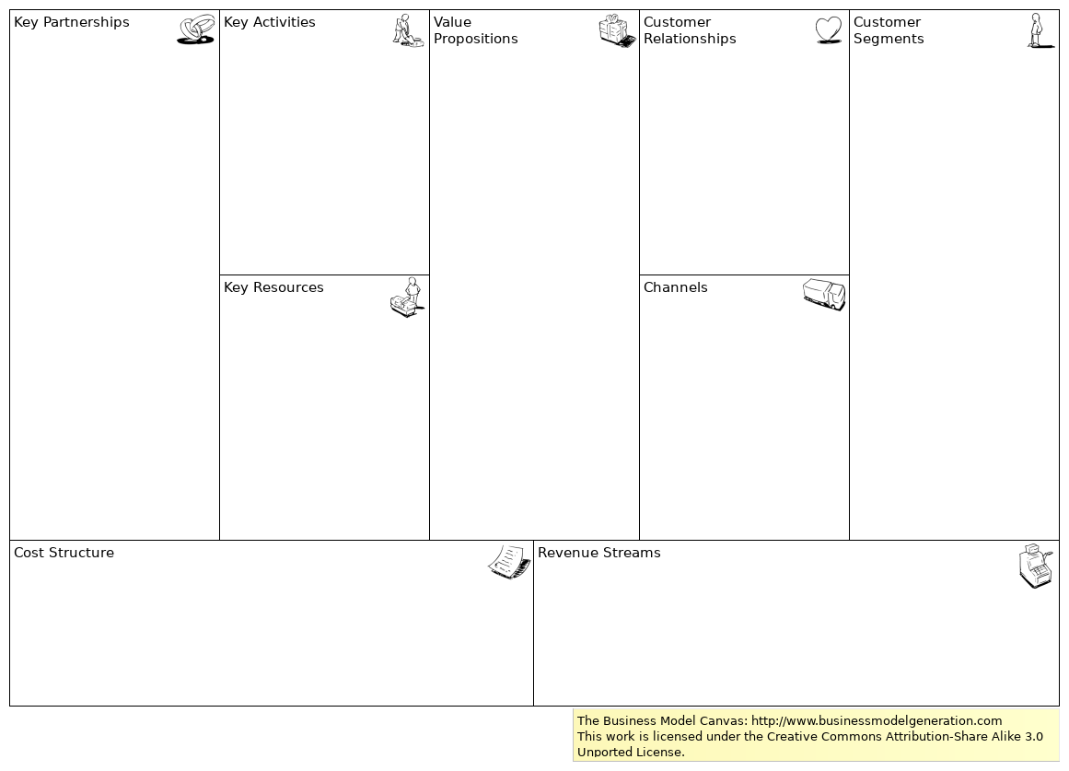
 | Documentation
The Business Model Canvas is a strategic management and entrepreneurial tool. It allows you to describe, design, challenge, invent, and pivot your business model.
For more information visit http://www.businessmodelgeneration.com
This work is licensed under the Creative Commons Attribution-Share Alike 3.0 Unported License. To view a copy of this license, visit http://creativecommons.org/licenses/by-sa/3.0/
 | Testing archi with github | 8 | / 52
 | Generated View for Commit changes
 | No viewpoint
 | 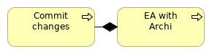
 | Elements
 | Element | Type
 | Commit changes | Business Process
 | EA with Archi | Business Process
 | Testing archi with github |  |  | 9 | / 52
 | Modelling process
 | No viewpoint
 | 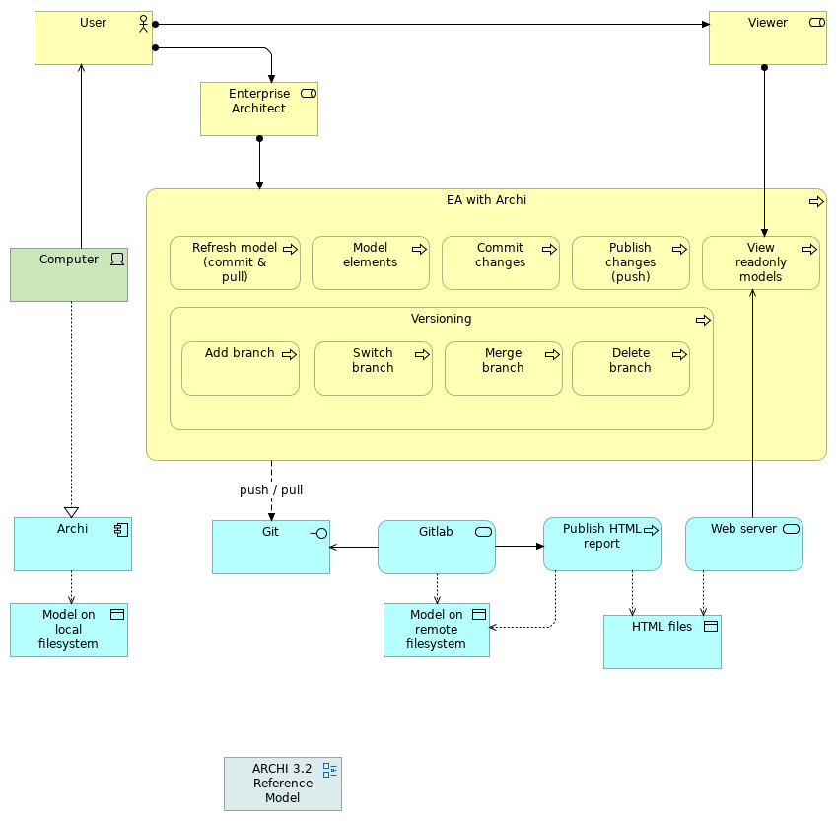
 | Elements
 | Element | Type
 | Add branch | Business Process
 | Archi | Application Component
 | Commit changes | Business Process
 | Computer | Device
 | Delete branch | Business Process
 | EA with Archi | Business Process
 | Enterprise Architect | Business Role
 | Git | Application Interface
 | Testing archi with github |  | 10 | / 52
 | Element | Type
 | Gitlab | Application Service
 | HTML files | Data Object
 | Merge branch | Business Process
 | Model elements | Business Process
 | Model on local filesystem | Data Object
 | Model on remote filesystem | Data Object
 | Publish changes (push) | Business Process
 | Publish HTML report | Application Process
 | Refresh model (commit & pull) | Business Process
 | Switch branch | Business Process
 | User | Business Actor
 | Versioning | Business Process
 | View readonly models | Business Process
 | Viewer | Business Role
 | Web server | Application Service
 | Testing archi with github |  | 11 | / 52
 | Sample canvas
 | 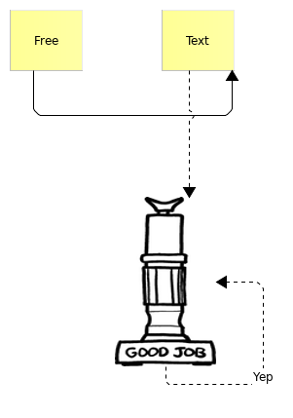
 | Testing archi with github |  | 12 | / 52
 | Sample view
 | No viewpoint
 | 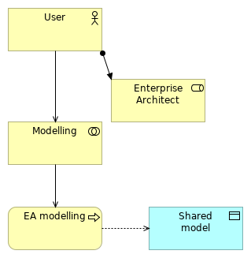
 | Elements
 | Element | Type
 | EA modelling | Business Process
 | Enterprise Architect | Business Role
 | Modelling | Business Collaboration
 | Shared model | Data Object
 | User | Business Actor
 | Testing archi with github |  |  | 13 | / 52
 | Sketching
 | 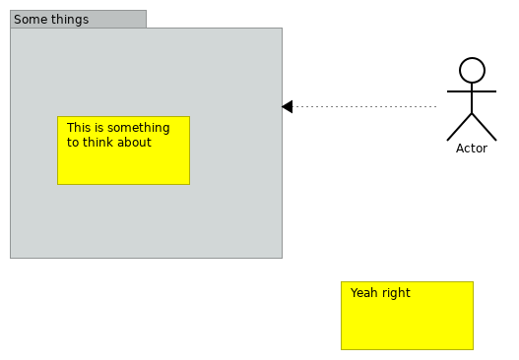
 | Testing archi with github | 14 | / 52
 | SWOT
 | 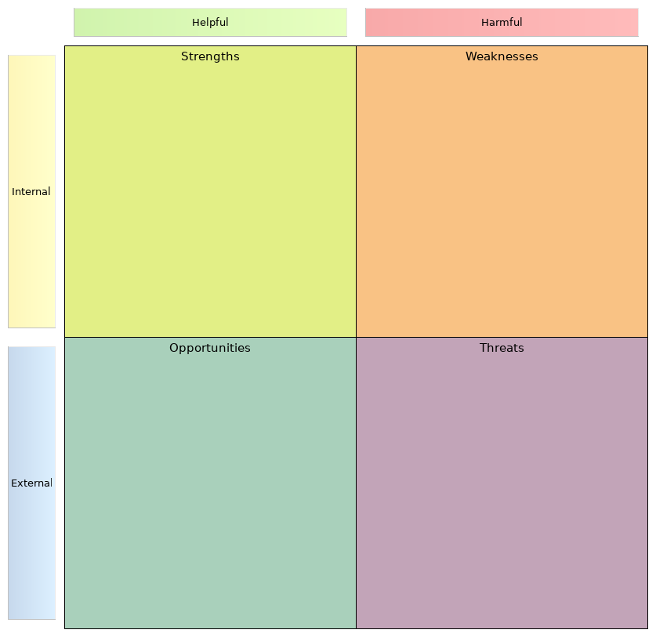
 | Documentation
SWOT analysis is a strategic planning method used to evaluate the Strengths, Weaknesses/Limitations, Opportunities, and Threats involved in a project or in a business venture.
It involves specifying the objective of the business venture or project and identifying the internal and external factors that are favorable and unfavorable to achieve that objective. The technique is credited to Albert Humphrey.
 | Testing archi with github | 15 | / 52
 | Testing archi with github | 16 | / 52
 | Strategy Layer
 | Value Stream
 | Type | Value Stream
 | Resource
 | Type | Resource
 | Course of Action
 | Type | Course of Action
 | Capability
 | Type | Capability
 | Capability
 | Type | Capability
 | Capability
 | Type | Capability
 | Course of Action
 | Type | Course of Action
 | Resource
 | Type | Resource
 | Value Stream
 | Type | Value Stream
 | Testing archi with github |  | 17 | / 52
 | Business Layer
 | Business Interaction
 | Type | Business Interaction
 | Business Interface
 | Type | Business Interface
 | Business Actor
 | Type | Business Actor
 | Business Event
 | Type | Business Event
 | Business Role
 | Type | Business Role
 | Business Collaboration
 | Type | Business Collaboration
 | Business Object
 | Type | Business Object
 | Product
 | Type | Product
 | Business Function
 | Type | Business Function
 | Business Service
 | Type | Business Service
 | Business Process
 | Type | Business Process
 | Contract
 | Type | Contract
 | Representation
 | Type | Representation
 | Add branch
 | Type | Business Process
 | Testing archi with github |  | 18 | / 52
 | Business Actor
 | Type | Business Actor
 | Business Collaboration
 | Type | Business Collaboration
 | Business Event
 | Type | Business Event
 | Business Function
 | Type | Business Function
 | Business Interaction
 | Type | Business Interaction
 | Business Interface
 | Type | Business Interface
 | Business Object
 | Type | Business Object
 | Business Object
 | Type | Business Object
 | Business Object (copy)
 | Type | Business Object
 | Business Object (copy) (copy)
 | Type | Business Object
 | Business Process
 | Type | Business Process
 | Business Process
 | Type | Business Process
 | Business Role
 | Type | Business Role
 | Business Service
 | Type | Business Service
 | Testing archi with github |  | 19 | / 52
 | Commit changes
 | Type | Business Process
 | Contract
 | Type | Contract
 | Delete branch
 | Type | Business Process
 | EA modelling
 | Type | Business Process
 | EA with Archi
 | Type | Business Process
 | Enterprise Architect
 | Type | Business Role
 | Enterprise Architect
 | Type | Business Role
 | Merge branch
 | Type | Business Process
 | Model elements
 | Type | Business Process
 | Modelling
 | Type | Business Collaboration
 | Product
 | Type | Product
 | Publish changes (push)
 | Type | Business Process
 | Refresh model (commit & pull)
 | Type | Business Process
 | Representation
 | Type | Representation
 | Testing archi with github |  | 20 | / 52
 | Switch branch
 | Type | Business Process
 | User
 | Type | Business Actor
 | User
 | Type | Business Actor
 | Versioning
 | Type | Business Process
 | View readonly models
 | Type | Business Process
 | Viewer
 | Type | Business Role
 | Testing archi with github |  | 21 | / 52
 | Application Layer
 | Application Service
 | Type | Application Service
 | Application Component
 | Type | Application Component
 | Application Function
 | Type | Application Function
 | Application Process
 | Type | Application Process
 | Application Collaboration
 | Type | Application Collaboration
 | Application Interface
 | Type | Application Interface
 | Application Event
 | Type | Application Event
 | Data Object
 | Type | Data Object
 | Application Interaction
 | Type | Application Interaction
 | Application Collaboration
 | Type | Application Collaboration
 | Application Component
 | Type | Application Component
 | Application Component
 | Type | Application Component
 | Application Event
 | Type | Application Event
 | Application Function
 | Type | Application Function
 | Testing archi with github |  | 22 | / 52
 | Application Interaction
 | Type | Application Interaction
 | Application Interface
 | Type | Application Interface
 | Application Process
 | Type | Application Process
 | Application Service
 | Type | Application Service
 | Archi
 | Type | Application Component
 | Data Object
 | Type | Data Object
 | Dummy
 | Type | Application Component
 | dummy
 | Type | Application Service
 | dummy
 | Type | Application Service
 | dummy (copy)
 | Type | Application Service
 | dummy (copy)
 | Type | Application Service
 | dummy (copy)
 | Type | Application Service
 | dummy (copy)
 | Type | Application Service
 | Dummy (copy)
 | Type | Application Component
 | Testing archi with github |  | 23 | / 52
 | dummy (copy)
 | Type | Application Service
 | dummy (copy)
 | Type | Application Service
 | dummy (copy) (copy)
 | Type | Application Service
 | dummy (copy) (copy)
 | Type | Application Service
 | Dummy (copy) (copy)
 | Type | Application Component
 | dummy (copy) (copy)
 | Type | Application Service
 | dummy (copy) (copy)
 | Type | Application Service
 | dummy (copy) (copy)
 | Type | Application Service
 | dummy (copy) (copy)
 | Type | Application Service
 | dummy (copy) (copy) (copy)
 | Type | Application Service
 | dummy (copy) (copy) (copy)
 | Type | Application Service
 | dummy (copy) (copy) (copy)
 | Type | Application Service
 | dummy (copy) (copy) (copy)
 | Type | Application Service
 | dummy (copy) (copy) (copy)
 | Type | Application Service
 | Testing archi with github |  | 24 | / 52
 | dummy (copy) (copy) (copy)
 | Type | Application Service
 | dummy (copy) (copy) (copy) (copy)
 | Type | Application Service
 | dummy (copy) (copy) (copy) (copy)
 | Type | Application Service
 | dummy (copy) (copy) (copy) (copy)
 | Type | Application Service
 | dummy (copy) (copy) (copy) (copy)
 | Type | Application Service
 | dummy (copy) (copy) (copy) (copy) (copy)
 | Type | Application Service
 | dummy (copy) (copy) (copy) (copy) (copy) (copy)
 | Type | Application Service
 | dummy (copy) (copy) (copy) (copy) (copy) (copy)
 | Type | Application Service
 | dummy (copy) (copy) (copy) (copy) (copy) (copy)
 | Type | Application Service
 | dummy (copy) (copy) (copy) (copy) (copy) (copy)
 | Type | Application Service
 | Git
 | Type | Application Interface
 | Gitlab
 | Type | Application Service
 | HTML files
 | Type | Data Object
 | Model on local filesystem
 | Type | Data Object
 | Testing archi with github |  | 25 | / 52
 | Model on remote filesystem
 | Type | Data Object
 | Publish HTML report
 | Type | Application Process
 | Publish report
 | Type | Application Process
 | Shared model
 | Type | Data Object
 | Web server
 | Type | Application Service
 | Testing archi with github |  | 26 | / 52
 | Technology & Physical Layer
 | Node
 | Type | Node
 | Technology Process
 | Type | Technology Process
 | System Software
 | Type | System Software
 | Technology Interaction
 | Type | Technology Interaction
 | Technology Interface
 | Type | Technology Interface
 | Technology Service
 | Type | Technology Service
 | Technology Function
 | Type | Technology Function
 | Technology Event
 | Type | Technology Event
 | Communication Network
 | Type | Communication Network
 | Path
 | Type | Path
 | Technology Collaboration
 | Type | Technology Collaboration
 | Device
 | Type | Device
 | Artifact
 | Type | Artifact
 | Artifact
 | Type | Artifact
 | Testing archi with github |  | 27 | / 52
 | Communication Network
 | Type | Communication Network
 | Computer
 | Type | Device
 | Device
 | Type | Device
 | Node
 | Type | Node
 | Path
 | Type | Path
 | System Software
 | Type | System Software
 | Technology Collaboration
 | Type | Technology Collaboration
 | Technology Event
 | Type | Technology Event
 | Technology Function
 | Type | Technology Function
 | Technology Interaction
 | Type | Technology Interaction
 | Technology Interface
 | Type | Technology Interface
 | Technology Process
 | Type | Technology Process
 | Technology Service
 | Type | Technology Service
 | Testing archi with github |  | 28 | / 52
 | Motivation
 | Principle
 | Type | Principle
 | Requirement
 | Type | Requirement
 | Meaning
 | Type | Meaning
 | Driver
 | Type | Driver
 | Outcome
 | Type | Outcome
 | Constraint
 | Type | Constraint
 | Stakeholder
 | Type | Stakeholder
 | Value
 | Type | Value
 | Assessment
 | Type | Assessment
 | Goal
 | Type | Goal
 | Assessment
 | Type | Assessment
 | Constraint
 | Type | Constraint
 | Driver
 | Type | Driver
 | dummy
 | Type | Requirement
 | Testing archi with github |  | 29 | / 52
 | dummy
 | Type | Outcome
 | Goal
 | Type | Goal
 | Meaning
 | Type | Meaning
 | Outcome
 | Type | Outcome
 | Principle
 | Type | Principle
 | Requirement
 | Type | Requirement
 | Stakeholder
 | Type | Stakeholder
 | Value
 | Type | Value
 | Testing archi with github |  | 30 | / 52
 | Implementation and Migration
 | Plateau
 | Type | Plateau
 | Implementation Event
 | Type | Implementation Event
 | Work Package
 | Type | Work Package
 | Deliverable
 | Type | Deliverable
 | Gap
 | Type | Gap
 | Deliverable
 | Type | Deliverable
 | Gap
 | Type | Gap
 | Implementation Event
 | Type | Implementation Event
 | Plateau
 | Type | Plateau
 | Work Package
 | Type | Work Package
 | Testing archi with github |  | 31 | / 52
 | Other
 | Grouping
 | Type | Grouping
 | Location
 | Type | Location
 | Application Layer
 | Type | Grouping
 | Business Layer
 | Type | Grouping
 | Goals View
 | Type | Grouping
 | Grouping
 | Type | Grouping
 | Implementation View
 | Type | Grouping
 | Junction
 | Type | Junction
 | Junction
 | Type | Junction
 | Junction (copy)
 | Type | Junction
 | Layered View
 | Type | Grouping
 | Location
 | Type | Location
 | Motivation view
 | Type | Grouping
 | Strategy View
 | Type | Grouping
 | Testing archi with github |  | 32 | / 52
 | Technology Layer
 | Type | Grouping
 | Testing archi with github |  | 33 | / 52
 | Relations
 | Triggering relation
 | Type | Triggering relation
 | Source | Gitlab
 | Target | Publish HTML report
 | Serving relation
 | Type | Serving relation
 | Source | User
 | Target | Modelling
 | Composition relation
 | Type | Composition relation
 | Source | Versioning
 | Target | Switch branch
 | Access relation
 | Type | Access relation
 | Source | Gitlab
 | Target | Model on remote filesystem
 | Assignment relation
 | Type | Assignment relation
 | Source | User
 | Target | Enterprise Architect
 | Access relation
 | Type | Access relation
 | Source | EA modelling
 | Target | Shared model
 | Serving relation
 | Type | Serving relation
 | Source | Modelling
 | Target | EA modelling
 | Composition relation
 | Type | Composition relation
 | Source | EA with Archi
 | Target | Merge branch
 | Composition relation
 | Type | Composition relation
 | Testing archi with github |  | 34 | / 52
 | Source | EA with Archi
 | Target | Publish changes (push)
 | Assignment relation
 | Type | Assignment relation
 | Source | User
 | Target | Viewer
 | Composition relation
 | Type | Composition relation
 | Source | EA with Archi
 | Target | Refresh model (commit & pull)
 | Access relation
 | Type | Access relation
 | Source | Web server
 | Target | HTML files
 | Flow relation
 | Type | Flow relation
 | Source | Git
 | Target | Gitlab
 | Serving relation
 | Type | Serving relation
 | Source | Gitlab
 | Target | Git
 | Composition relation
 | Type | Composition relation
 | Source | EA with Archi
 | Target | Delete branch
 | Composition relation
 | Type | Composition relation
 | Source | EA with Archi
 | Target | Commit changes
 | Serving relation
 | Type | Serving relation
 | Source | Web server
 | Target | View readonly models
 | Testing archi with github |  | 35 | / 52
 | Realization relation
 | Type | Realization relation
 | Source | Modelling
 | Target | Capability
 | Composition relation
 | Type | Composition relation
 | Source | Versioning
 | Target | Delete branch
 | Access relation
 | Type | Access relation
 | Source | Publish HTML report
 | Target | Model on remote filesystem
 | Composition relation
 | Type | Composition relation
 | Source | EA with Archi
 | Target | Model elements
 | Assignment relation
 | Type | Assignment relation
 | Source | Viewer
 | Target | View readonly models
 | Composition relation
 | Type | Composition relation
 | Source | Versioning
 | Target | Merge branch
 | Access relation
 | Type | Access relation
 | Source | Publish HTML report
 | Target | HTML files
 | Assignment relation
 | Type | Assignment relation
 | Source | Enterprise Architect
 | Target | EA with Archi
 | Realization relation
 | Type | Realization relation
 | Source | Computer
 | Target | Archi
 | Testing archi with github |  | 36 | / 52
 | Composition relation
 | Type | Composition relation
 | Source | EA with Archi
 | Target | Add branch
 | Composition relation
 | Type | Composition relation
 | Source | EA with Archi
 | Target | Versioning
 | Composition relation
 | Type | Composition relation
 | Source | EA with Archi
 | Target | View readonly models
 | Composition relation
 | Type | Composition relation
 | Source | Versioning
 | Target | Add branch
 | Access relation
 | Type | Access relation
 | Source | Archi
 | Target | Model on local filesystem
 | Assignment relation
 | Type | Assignment relation
 | Source | User
 | Target | Enterprise Architect
 | Composition relation
 | Type | Composition relation
 | Source | EA with Archi
 | Target | Switch branch
 | Serving relation
 | Type | Serving relation
 | Source | Computer
 | Target | User
 | Composition relation
 | Type | Composition relation
 | Source | Strategy View
 | Testing archi with github |  | 37 | / 52
 | Target | Value Stream
 | Composition relation
 | Type | Composition relation
 | Source | Goals View
 | Target | Stakeholder
 | Composition relation
 | Type | Composition relation
 | Source | Business Layer
 | Target | Business Object
 | Composition relation
 | Type | Composition relation
 | Source | Business Layer
 | Target | Business Interface
 | Composition relation
 | Type | Composition relation
 | Source | Application Layer
 | Target | Application Service
 | Composition relation
 | Type | Composition relation
 | Source | Technology Layer
 | Target | Technology Interface
 | Composition relation
 | Type | Composition relation
 | Source | Business Layer
 | Target | Representation
 | Composition relation
 | Type | Composition relation
 | Source | Technology Layer
 | Target | System Software
 | Composition relation
 | Type | Composition relation
 | Source | Goals View
 | Target | Value
 | Access relation
 | Type | Access relation
 | Testing archi with github |  | 38 | / 52
 | Source | Business Process
 | Target | Business Object
 | Association relation
 | Type | Association relation
 | Source | Assessment
 | Target | Goal
 | Composition relation
 | Type | Composition relation
 | Source | Technology Layer
 | Target | Technology Service
 | Composition relation
 | Type | Composition relation
 | Source | Goals View
 | Target | Goal
 | Composition relation
 | Type | Composition relation
 | Source | Goals View
 | Target | Requirement
 | Composition relation
 | Type | Composition relation
 | Source | Strategy View
 | Target | Resource
 | Realization relation
 | Type | Realization relation
 | Source | Representation
 | Target | Contract
 | Association relation
 | Type | Association relation
 | Source | Driver
 | Target | Assessment
 | Composition relation
 | Type | Composition relation
 | Source | Business Layer
 | Target | Business Service
 | Testing archi with github |  | 39 | / 52
 | Composition relation
 | Type | Composition relation
 | Source | Application Layer
 | Target | Application Process
 | Composition relation
 | Type | Composition relation
 | Source | Technology Layer
 | Target | Technology Process
 | Composition relation
 | Type | Composition relation
 | Source | Application Layer
 | Target | Data Object
 | Association relation
 | Type | Association relation
 | Source | Plateau
 | Target | Gap
 | Composition relation
 | Type | Composition relation
 | Source | Business Layer
 | Target | Business Actor
 | Composition relation
 | Type | Composition relation
 | Source | Strategy View
 | Target | Course of Action
 | Composition relation
 | Type | Composition relation
 | Source | Technology Layer
 | Target | Device
 | Association relation
 | Type | Association relation
 | Source | Assessment
 | Target | Outcome
 | Composition relation
 | Type | Composition relation
 | Source | Goals View
 | Target | Constraint
 | Testing archi with github |  | 40 | / 52
 | Composition relation
 | Type | Composition relation
 | Source | Technology Layer
 | Target | Communication Network
 | Composition relation
 | Type | Composition relation
 | Source | Motivation view
 | Target | Goals View
 | Composition relation
 | Type | Composition relation
 | Source | Implementation View
 | Target | Deliverable
 | Composition relation
 | Type | Composition relation
 | Source | Business Layer
 | Target | Business Role
 | Association relation
 | Type | Association relation
 | Source | Contract
 | Target | Business Service
 | Composition relation
 | Type | Composition relation
 | Source | Application Layer
 | Target | Application Event
 | Composition relation
 | Type | Composition relation
 | Source | Layered View
 | Target | Application Layer
 | Composition relation
 | Type | Composition relation
 | Source | Technology Layer
 | Target | Technology Event
 | Association relation
 | Type | Association relation
 | Source | Driver
 | Testing archi with github |  | 41 | / 52
 | Target | Goal
 | Composition relation
 | Type | Composition relation
 | Source | Business Layer
 | Target | Business Process
 | Composition relation
 | Type | Composition relation
 | Source | Goals View
 | Target | Assessment
 | Composition relation
 | Type | Composition relation
 | Source | Technology Layer
 | Target | Node
 | Association relation
 | Type | Association relation
 | Source | Stakeholder
 | Target | Driver
 | Composition relation
 | Type | Composition relation
 | Source | Business Layer
 | Target | Product
 | Composition relation
 | Type | Composition relation
 | Source | Goals View
 | Target | Principle
 | Composition relation
 | Type | Composition relation
 | Source | Layered View
 | Target | Technology Layer
 | Composition relation
 | Type | Composition relation
 | Source | Implementation View
 | Target | Work Package
 | Composition relation
 | Type | Composition relation
 | Testing archi with github |  | 42 | / 52
 | Source | Application Layer
 | Target | Application Component
 | Composition relation
 | Type | Composition relation
 | Source | Business Layer
 | Target | Contract
 | Composition relation
 | Type | Composition relation
 | Source | Goals View
 | Target | Outcome
 | Composition relation
 | Type | Composition relation
 | Source | Technology Layer
 | Target | Artifact
 | Composition relation
 | Type | Composition relation
 | Source | Implementation View
 | Target | Plateau
 | Composition relation
 | Type | Composition relation
 | Source | Strategy View
 | Target | Capability
 | Composition relation
 | Type | Composition relation
 | Source | Implementation View
 | Target | Gap
 | Composition relation
 | Type | Composition relation
 | Source | Application Layer
 | Target | Application Interface
 | Composition relation
 | Type | Composition relation
 | Source | Goals View
 | Target | Driver
 | Testing archi with github |  | 43 | / 52
 | Composition relation
 | Type | Composition relation
 | Source | Motivation view
 | Target | Strategy View
 | Composition relation
 | Type | Composition relation
 | Source | Layered View
 | Target | Business Layer
 | Composition relation
 | Type | Composition relation
 | Source | Business Layer
 | Target | Business Event
 | Access relation
 | Type | Access relation
 | Source | dummy (copy) (copy)
 | Target | Business Object
 | Access relation
 | Type | Access relation
 | Source | dummy (copy) (copy) (copy)
 | Target | Business Object (copy)
 | Association relation
 | Type | Association relation
 | Source | Dummy (copy) (copy)
 | Target | dummy (copy) (copy) (copy) (copy)
 | Composition relation
 | Type | Composition relation
 | Source | dummy
 | Target | dummy
 | Flow relation
 | Type | Flow relation
 | Source | dummy (copy) (copy) (copy)
 | Target | dummy (copy) (copy) (copy)
 | Access relation
 | Type | Access relation
 | Source | dummy (copy) (copy) (copy) (copy)
 | Target | Business Object (copy) (copy)
 | Testing archi with github |  | 44 | / 52
 | Serving relation
 | Type | Serving relation
 | Source | dummy (copy)
 | Target | dummy (copy)
 | Realization relation
 | Type | Realization relation
 | Source | dummy (copy) (copy)
 | Target | dummy
 | Specialization relation
 | Type | Specialization relation
 | Source | dummy (copy) (copy) (copy)
 | Target | dummy (copy) (copy) (copy)
 | Aggregation relation
 | Type | Aggregation relation
 | Source | dummy (copy)
 | Target | dummy (copy)
 | Assignment relation
 | Type | Assignment relation
 | Source | Dummy
 | Target | dummy (copy) (copy)
 | Triggering relation
 | Type | Triggering relation
 | Source | dummy (copy) (copy)
 | Target | dummy (copy) (copy)
 | Realization relation
 | Type | Realization relation
 | Source | Dummy (copy)
 | Target | dummy (copy) (copy) (copy)
 | Influence relation
 | Type | Influence relation
 | Source | dummy
 | Target | dummy
 | access
 | Type | Access relation
 | Source | Technology Process
 | Testing archi with github |  | 45 | / 52
 | Target | Artifact
 | access
 | Type | Access relation
 | Source | Application Process
 | Target | Data Object
 | aggregation
 | Type | Aggregation relation
 | Source | Node
 | Target | Device
 | aggregation
 | Type | Aggregation relation
 | Source | Node
 | Target | System Software
 | aggregation
 | Type | Aggregation relation
 | Source | Product
 | Target | Business Service
 | assignment
 | Type | Assignment relation
 | Source | Application Component
 | Target | Application Process
 | assignment
 | Type | Assignment relation
 | Source | Resource
 | Target | Capability
 | assignment
 | Type | Assignment relation
 | Source | Business Actor
 | Target | Business Process
 | assignment
 | Type | Assignment relation
 | Source | Node
 | Target | Technology Process
 | assignment
 | Type | Assignment relation
 | Testing archi with github |  | 46 | / 52
 | Source | Business Interface
 | Target | Business Service
 | assignment
 | Type | Assignment relation
 | Source | Node
 | Target | Artifact
 | assignment
 | Type | Assignment relation
 | Source | Business Actor
 | Target | Business Role
 | assignment
 | Type | Assignment relation
 | Source | Application Interface
 | Target | Application Service
 | assignment
 | Type | Assignment relation
 | Source | Device
 | Target | System Software
 | assignment
 | Type | Assignment relation
 | Source | Technology Interface
 | Target | Technology Service
 | association
 | Type | Association relation
 | Source | Outcome
 | Target | Value
 | association
 | Type | Association relation
 | Source | Value
 | Target | Layered View
 | association
 | Type | Association relation
 | Source | Stakeholder
 | Target | Value
 | Testing archi with github |  | 47 | / 52
 | association
 | Type | Association relation
 | Source | Value Stream
 | Target | Value
 | association
 | Type | Association relation
 | Source | Communication Network
 | Target | Device
 | composition
 | Type | Composition relation
 | Source | Business Actor
 | Target | Business Interface
 | composition
 | Type | Composition relation
 | Source | Application Component
 | Target | Application Interface
 | composition
 | Type | Composition relation
 | Source | Node
 | Target | Technology Interface
 | flow
 | Type | Flow relation
 | Source | Application Component
 | Target | Application Component
 | flow
 | Type | Flow relation
 | Source | Business Process
 | Target | Business Process
 | flow
 | Type | Flow relation
 | Source | Business Actor
 | Target | Business Actor
 | flow
 | Type | Flow relation
 | Source | Business Actor
 | Target | Business Actor
 | Testing archi with github |  | 48 | / 52
 | push / pull
 | Type | Flow relation
 | Source | EA with Archi
 | Target | Git
 | realization
 | Type | Realization relation
 | Source | Requirement
 | Target | Principle
 | realization
 | Type | Realization relation
 | Source | Artifact
 | Target | Data Object
 | realization
 | Type | Realization relation
 | Source | Deliverable
 | Target | Layered View
 | realization
 | Type | Realization relation
 | Source | Application Process
 | Target | Application Service
 | realization
 | Type | Realization relation
 | Source | Deliverable
 | Target | Plateau
 | realization
 | Type | Realization relation
 | Source | Constraint
 | Target | Outcome
 | realization
 | Type | Realization relation
 | Source | Course of Action
 | Target | Requirement
 | realization
 | Type | Realization relation
 | Source | Requirement
 | Testing archi with github |  | 49 | / 52
 | Target | Outcome
 | realization
 | Type | Realization relation
 | Source | Representation
 | Target | Business Object
 | realization
 | Type | Realization relation
 | Source | Data Object
 | Target | Business Object
 | realization
 | Type | Realization relation
 | Source | Business Process
 | Target | Business Service
 | realization
 | Type | Realization relation
 | Source | Value Stream
 | Target | Course of Action
 | realization
 | Type | Realization relation
 | Source | Principle
 | Target | Outcome
 | realization
 | Type | Realization relation
 | Source | Layered View
 | Target | Motivation view
 | realization
 | Type | Realization relation
 | Source | Technology Process
 | Target | Technology Service
 | realization
 | Type | Realization relation
 | Source | Work Package
 | Target | Deliverable
 | realization
 | Type | Realization relation
 | Testing archi with github |  | 50 | / 52
 | Source | Capability
 | Target | Course of Action
 | serving
 | Type | Serving relation
 | Source | Business Interface
 | Target | Business Actor
 | serving
 | Type | Serving relation
 | Source | Product
 | Target | Business Role
 | serving
 | Type | Serving relation
 | Source | Capability
 | Target | Value Stream
 | serving
 | Type | Serving relation
 | Source | Business Service
 | Target | Business Role
 | serving
 | Type | Serving relation
 | Source | Technology Service
 | Target | Application Process
 | serving
 | Type | Serving relation
 | Source | Application Service
 | Target | Application Component
 | serving
 | Type | Serving relation
 | Source | Application Service
 | Target | Business Process
 | serving
 | Type | Serving relation
 | Source | Technology Interface
 | Target | Application Component
 | Testing archi with github |  | 51 | / 52
 | serving
 | Type | Serving relation
 | Source | Application Interface
 | Target | Business Actor
 | trigger
 | Type | Triggering relation
 | Source | Business Event
 | Target | Business Process
 | trigger
 | Type | Triggering relation
 | Source | Technology Event
 | Target | Technology Process
 | trigger
 | Type | Triggering relation
 | Source | Application Event
 | Target | Application Process
 | Testing archi with github |  | 52 | / 52

